**Racial Disparity between Asian Americans and Other Racial Groups in the United States**

Lengyi Zhang

**Introduction**

During the Covid-19 pandemic, Asian-Americans have constantly been the victims of racial discrimination and physical violence [1]. Many in the community have spoken out about their experiences of racism in the past year. Without any doubt, the United States is still deeply trapped in its long history of racism, and it affects all racial minorities, more or less. While it is rather intuitive to imagine Asian-Americans are natural allies with other racial minorities, such as African Americans, some incidents reveal how opinions on racism diverge dramatically among Asian-Americans. For example, many Asian-Americans protest against affirmative action since they believe that they have been unfairly treated compared to other racial minorities [2]. In addition, as an international student from China, I was surprised by many Asian-Americans’ reticence and indifference during the nationwide marches for George Floyd’s death.

What creates these divides of opinions in the Asian-American community? Why do many of them seem unable to empathize with African Americans’ struggles? Of course, these are very complex questions, and I cannot obtain a comprehensive or profound conclusion as a debutante in data science. However, we might be able to find some clues towards this conclusion by analyzing racial disparity between Asian-Americans, African Americans, and white Americans.

In this research, my main questions are: Compared to African Americans, are Asian-Americans “better off” regarding their living conditions? Compared to white Americans? To evaluate each racial group’s living conditions, I will choose obesity, education, and income to be the criteria for this research.

**Dataset**

In this project, we used the National Health and Nutrition Examination Survey(NHANES) 2009-2012 dataset [3] to analyze the relationships between race, body mass index(BMI), education level, and median household income. In fact, the greatest difficulty that we encountered for this research is data limitation. Although some datasets might contain one or two categories of data we need, they do not include all categories at the same time as the NHANES dataset does. In addition, the NHANES dataset contains detailed information of each individual; its proportion of each racial group is also in accordance with the reality in the United States (white Americans significantly outnumber Asian-Americans and African Americans).

**Statistical Analysis**

Statistical analysis was done using Numpy, Pandas and Matplotlib packages in Python 3.8. All codes can be found in: <https://github.com/LengyiZhang/Final_Project_Stats.git>

**Race and Obesity**

First, we examine the relationship between race and obesity level, as we understand that obesity can be a very important indicator for many health-related problems. In this project, we determine the samples’ obesity levels based on their BMI data. The criteria used to categorize BMI are based on a report in the Science magazine [4].

In Figure 1, we can easily see how the proportion of people who are “normal” among Asian-Americans is significantly higher than the proportions in African Americans and in white Americans. In addition, the proportion of people who reach the level of “obesity” among Asian-Americans is significantly lower than the proportions in African Americans and in white Americans. In contrast, African Americans have larger proportions of people who reach the levels of “obesity” and “severe obesity” compared to white Americans. If Asian-Americans’ average BMI is lower than white Americans’ in a statistically significant way, then we can argue Asian-Americans struggle much less with obesity-related problems as a racial minority, compared to African Americans.

The average BMI of Asian-Americans is 23.651(95% CI = [22.997, 24.306]). The average BMI of white Americans is 26.599 (95% CI = [26.350, 26.847]). We conduct a two-sample t test to compare the average BMI of Asian-Americans and white Americans. There is no significant difference between the BMI of these two racial groups (p>0.001). The average difference between their BMI is -2.948 (95% CI = [-3.648, -2.247]).

Thus, we can conclude: regarding obesity level, Asian-Americans have a lower average BMI than white Americans. It indicates that Asian-Americans would also have less obesity-related health problems compared to white Americans, not even mentioning African Americans.

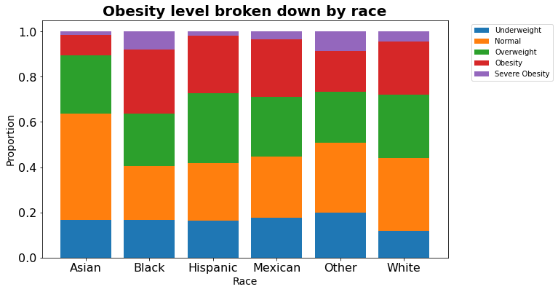

*Figure 1: Obesity level vs race in the United States*

*\*Data Source: NHANES 2009 - 2012*

**Race and Income**

Second, we examine the relationship between race and income level. In this project, we choose “median household income” to be our indicator of income level.

In Figure 2, we can see that Asian-Americans, African Americans, and white Americans share a very similar range from their minimum to their maximum median household income. However, the majority of each racial group occupies a different range of median household income in this boxplot. We can see the average median household incomes of Asian-Americans and white Americans are obviously higher than the one of African Americans.

The average median household income of Asian-Americans is 65313.765 (95% CI = [61494.063, 69133.467]). The average median household income of white Americans is 63055.556 (95% CI = [61899.523,64211.588]). The average difference between their median household income is $2258.209 (95% CI = [-1732.596, 6249.016]). We conduct a two-sample t test to compare the average median household incomes of Asian-Americans and of white Americans. There is no significant difference between the median household incomes of these two racial groups (p>0.001). However, if we conduct a two-sample t test to compare the average median household incomes of Asian-Americans and of African Americans, there is a very significant difference between the median household incomes of these two racial groups (p<0.001).

Thus, we can conclude: regarding income level, Asian-Americans have a slightly higher average income than white Americans. Moreover, Asian-Americans’ economic status is much better compared to African Americans.

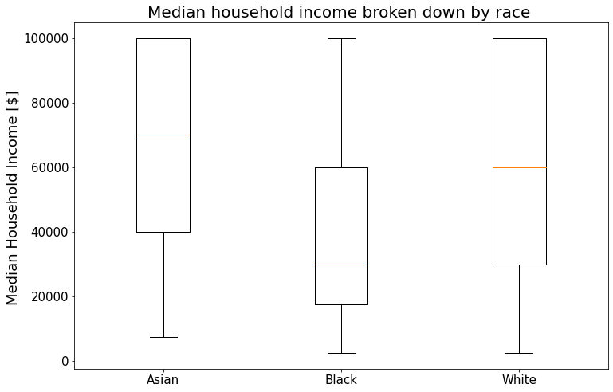

*Figure 2: Median household income vs race in the United States*

*\*Data Source: NHANES 2009 - 2012*

So far, we have explored two dimensions of living conditions (obesity and income), and they both indicate that Asian-Americans have better health and economic statuses compared to white Americans and African Americans. it seems more intuitive to think that obesity has a stronger correlation with one’s income level instead of one’s race. Therefore, we will briefly examine the relationship between income and obesity, so we see how important race is as an affecting factor.

In Figure 3, a scatter plot indicates the relationship between median household income and BMI for all samples in this NHANES dataset. A simple linear regression analysis is conducted to examine this relationship. A significant regression equation is found (p<0.001). The equation is BMI = Median household income [US$10000] * -1.429e-05 + 27.5116. Thus, the person’s BMI decreases 1.429e-05 (95% CI [1.19e-05, 1.668e--05]) for every US $10000 of household income. The correlation coefficient between the two variables is -0.064 (p<0.001). As the correlation coefficient is very low, we can conclude that there is almost no relationship between BMI and household income even though a regression line is obtained. Race has a stronger association with both obesity and household income than the one that they have with each other.

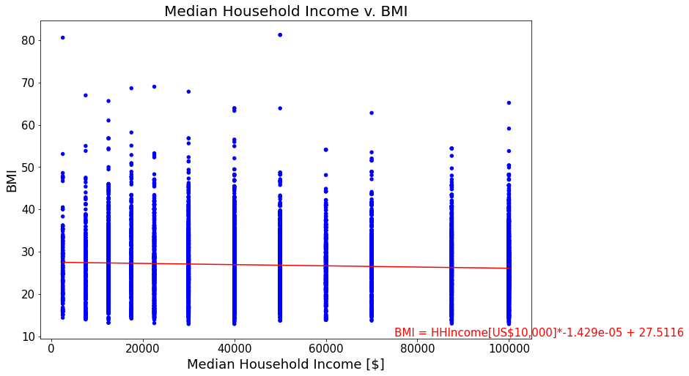

*Figure 3: Relationship between income and obesity*

*\*Data Source: NHANES 2009 - 2012*

**Race and Gender**

In the previous section, we have seen that Asian-Americans and white Americans have a similar level of household income. However, is there any gender disparity among these two racial communities? Therefore, we set up two grouped histograms to compare male and female income among Asian-Aemricans and white Americans.

In Figure 4, we can see the comparison of income levels between white men and white women. For the range where the median household income is lower than $50000, women are more than men; more men have income higher than $50000 than their female counterparts. The average median household income of white men is 65208.192 (95% CI = [63558.524, 62627.594]). The average median household income of white women is 60925.988 (95% CI = [59224.382, 62627.594]). The average difference between their median household income is $4282.204 (95% CI = [1912.210, 6652.198]).

In Figure 5, we can see the comparison of income levels between Asian men and Asian women. For the range where the median household income is lower than $50000, men are more than women; more women have income higher than $50000 than their male counterparts. The average median household income of Asian men is 63256.303 (95% CI = [57347.643, 69164.962]). The average median household income of Asian women is 67226.563 (95% CI = [61486.868, 72966.257]). The average difference between their median household income is $-3970.260 (95% CI = [-12207.757, 4267.237]).

We conduct a two-sample t test to compare the average median household incomes of male and female Asian-Americans. There is no significant difference between the median household incomes of these two gender groups (p>0.001). However, if we conduct a two-sample t test to compare the average median household incomes between male and female white Americans and of African Americans, there is a significant difference between the median household incomes of these two gender groups (p<0.001). Therefore, we can conclude that the gender economic difference among Asian-Americans is smaller than the one among white Americans.

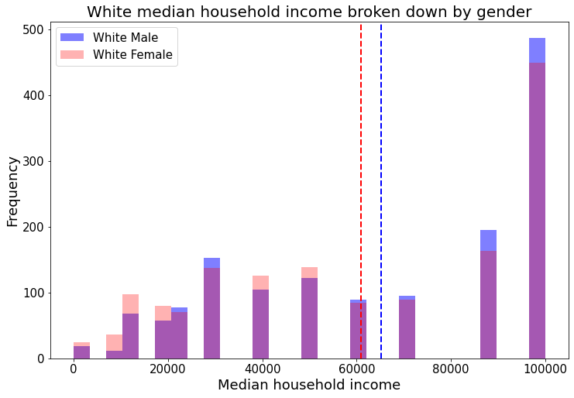

*Figure 4: A grouped histogram to show white Americans’ median household income broken down by gender*

*\*Data Source: NHANES 2009 - 2012*

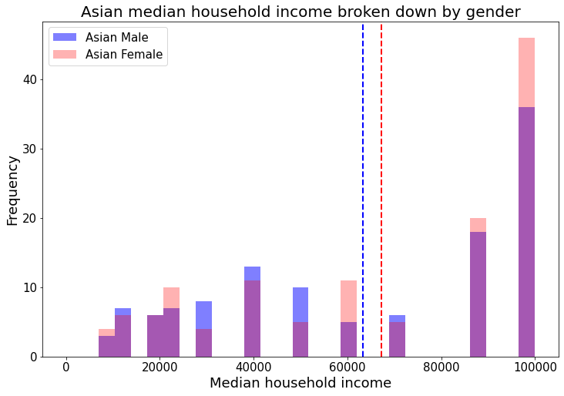

*Figure 5: A grouped histogram to show Asian median household income broken down by gender*

*\*Data Source: NHANES 2009 - 2012*

**Race and Education**

In Figure 6, we can see the comparison of education levels between Asian-Americans and other racial groups. We can easily see that Asian Americans have the largest proportion of college graduates among all racial communities, even larger than white Americans. The proportion of college graduates and college dropouts among Asian-Americans is almost 80%, much higher than white Americans and other racial minorities.

The sample proportion of Asian-Americans who have a bachelor degree is 0.0975 (95% CI = [0.0802, 0.115]). The sample proportion of non-Asian people who have a bachelor degree among all college graduates is 0.902 (95% CI = [0.885, 0.920]). The proportion difference between Asian-American college graduates and non-Asian college graduates is 0.225 (95% CI = [0.155, 0.294]). We conduct a chi-squared test to see whether being Asian-American and having a bachelor degree has any association. It turns out that there is a significant association (p<0.001). Therefore, we can conclude that more Asian-Americans obtain higher education compared to other racial communities.

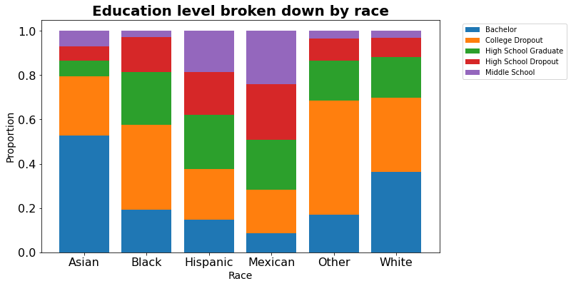

*Figure 6: A stacked bar chart to show the proportion of each education level among different racial groups*

*\*Data Source: NHANES 2009 - 2012*

**Conclusion**

Based on the statistical analysis above, we can conclude: Asian-Americans’ living conditions, at least on the dimensions of obesity, income, gender, and education, are very different from people’s imagination of “underprivileged racial minorities”. According to the NHANES 2009-2012 dataset, Asian-Americans have a smaller proportion of the population who have obesity, and a larger proportion who have a bachelor degree and higher household income. The gender disparity of household income seems less significant among Asian-Americans than among other racial communities. However, it does not mean that Asian-Americans do not struggle with institutional racism, which might manifest in many other dimensions: mental health, work environment friendliness, etc.

This research only provides a limited perspective, since it is only based on the dataset in the NHANES 2009-2012. The number of samples might not be sufficient to add more certainty to this conclusion. However, the results of these data analyses still can provide some clues for us to comprehend the indifferent attitude towards anti-racism among some Asian-Americans.

**Citation**

[1]Delaney, R. (2020, June 16). Black Lives Matter movement reveals divides among Asian-American community. Retrieved December 14, 2020, from https://www.scmp.com/news/china/article/3089169/black-lives-matter-movement-reveals-divides-among-asian-american

[2]Salanga, J. (2020, October 29). Asian-American students divided over affirmative action. Retrieved December 14, 2020, from https://calmatters.org/education/higher-education/college-beat-higher-education/2020/10/asian-american-students-affirmative-action/

[3] [National Health and Nutrition Examination Survey 2009-2012]. (n.d.). Unpublished raw data.

[4]Wadman, M. (2020, November 30). Why COVID-19 is more deadly in people with obesity-even if they're young. Retrieved December 14, 2020, from https://www.sciencemag.org/news/2020/09/why-covid-19-more-deadly-people-obesity-even-if-theyre-young